Q2 Create a vpc endpoint for s3 bucket and access it using the ec2 instance.

ANS :

Create a VPC:

Go to the VPC service in the AWS Management Console.

Create a new VPC with your desired configuration (CIDR block, availability zones).

Create a Subnet:

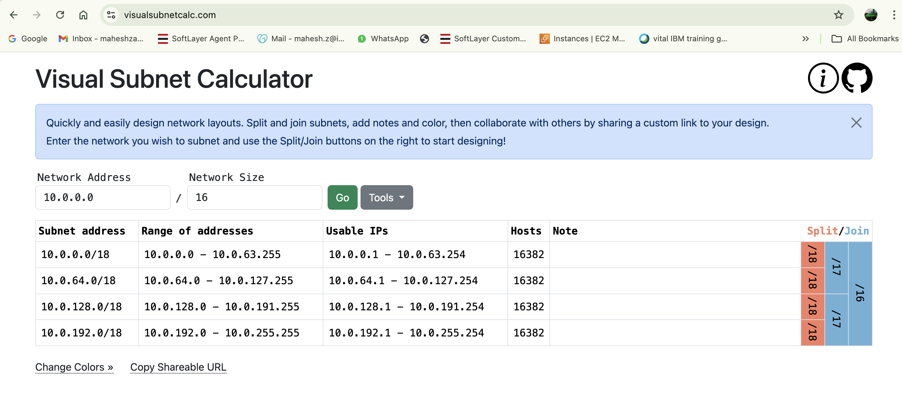

Create VPC

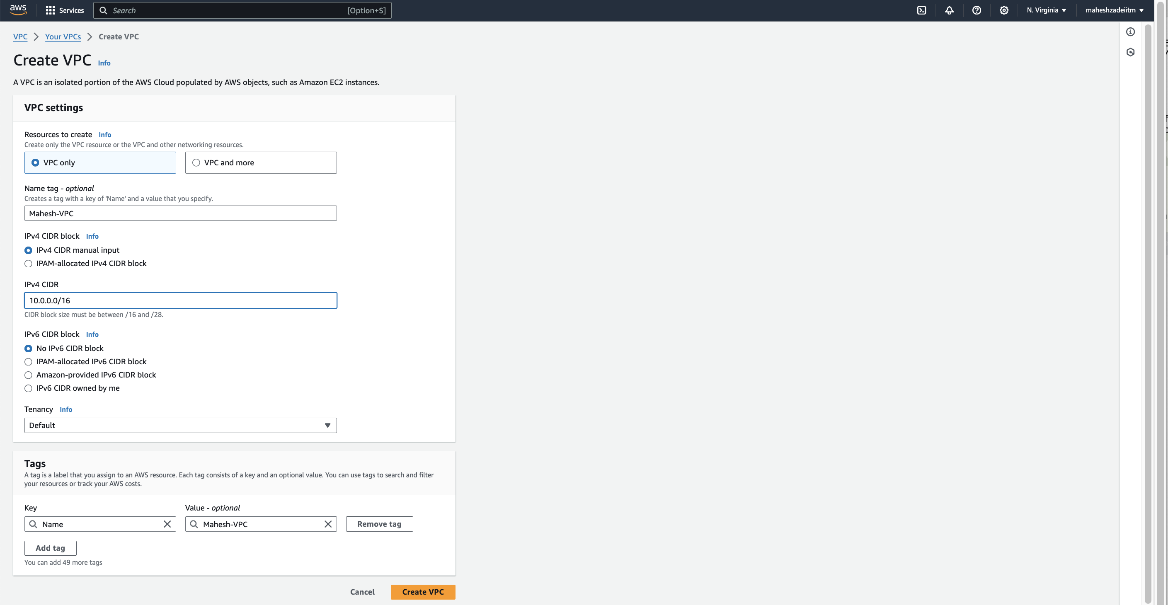

VPC Created

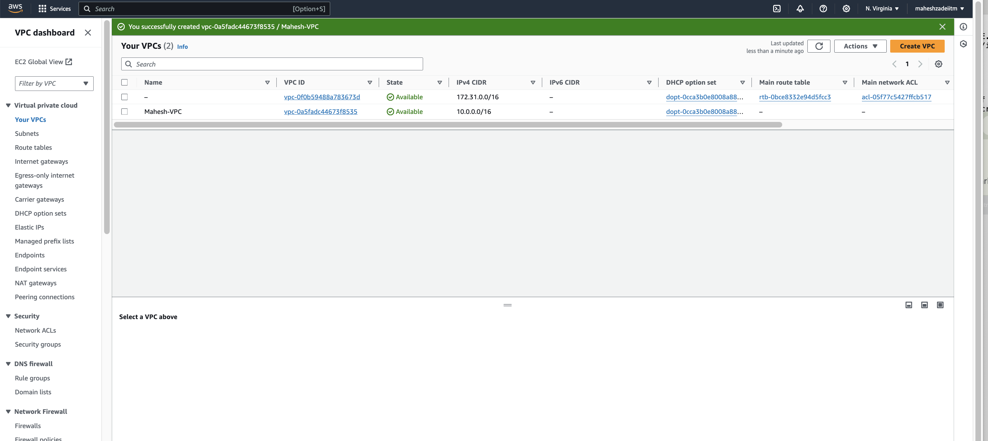

Within your VPC, create a subnet in the availability zone where you want to launch your EC2 instance.

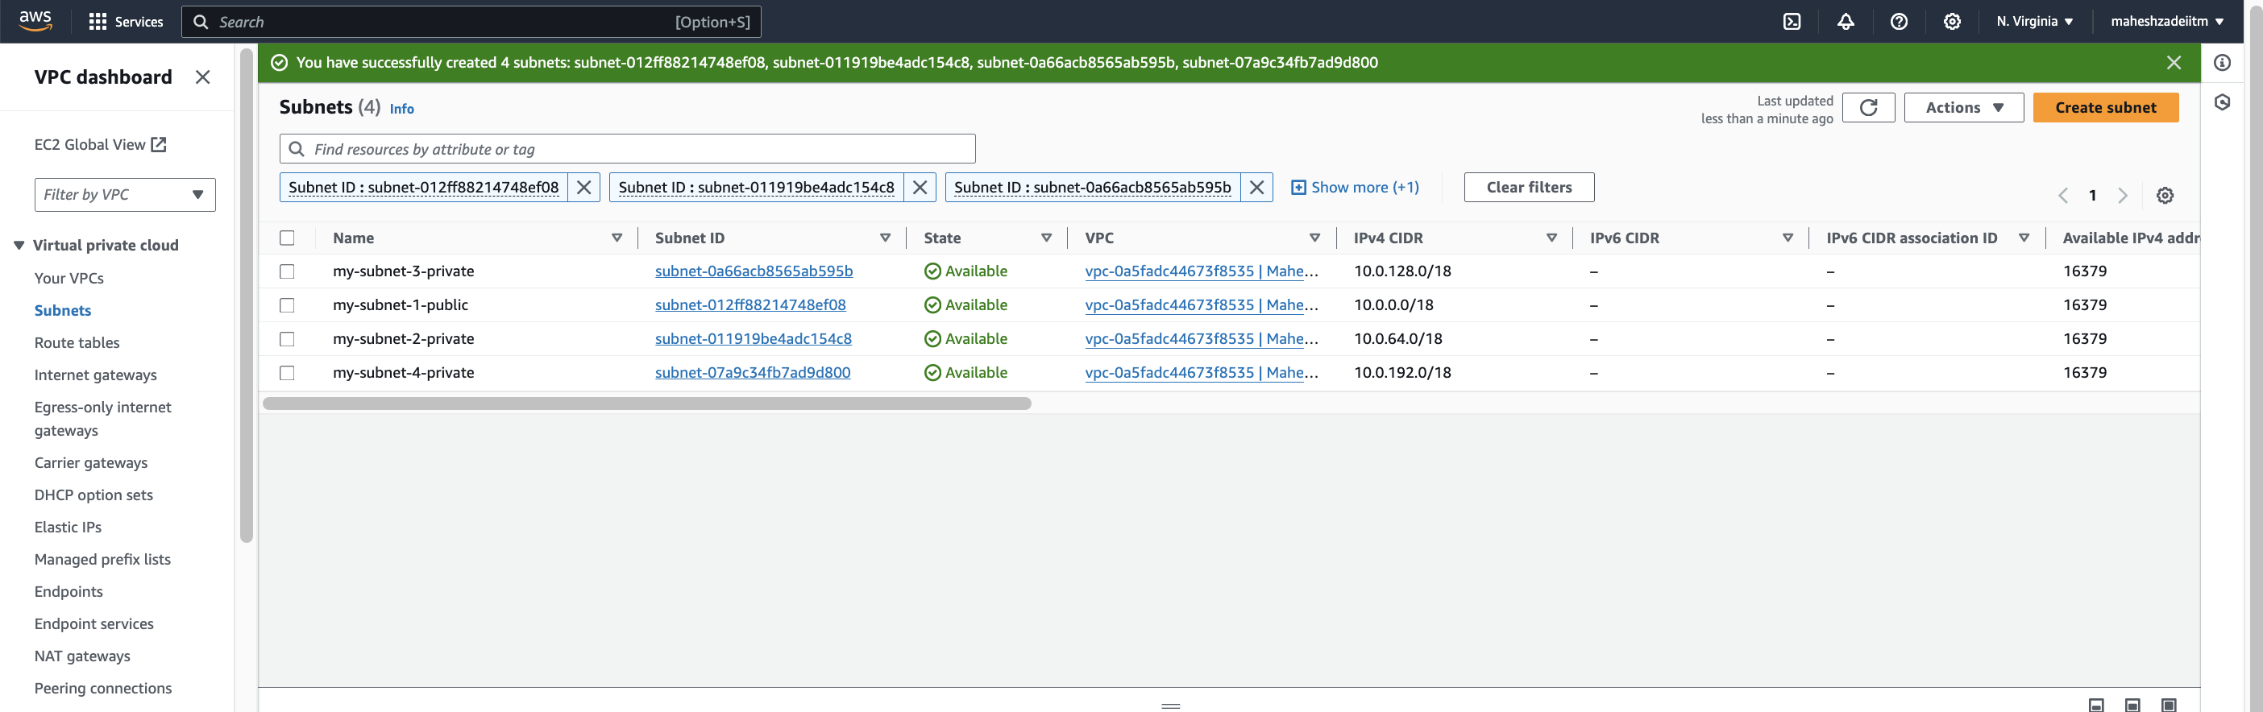

Crated Internet gateway

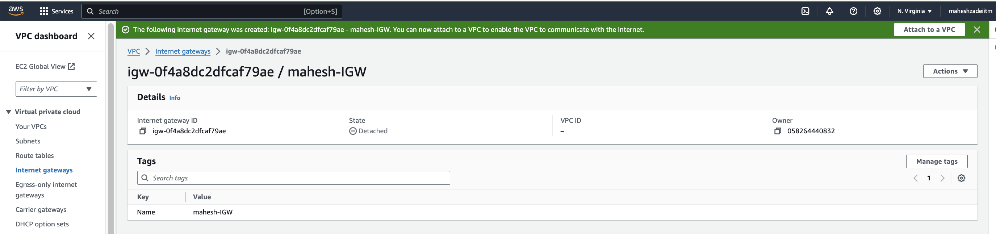

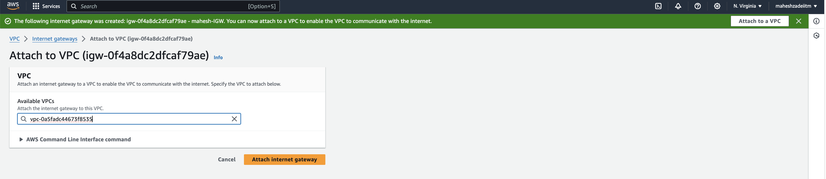

Gateway attached to VPC

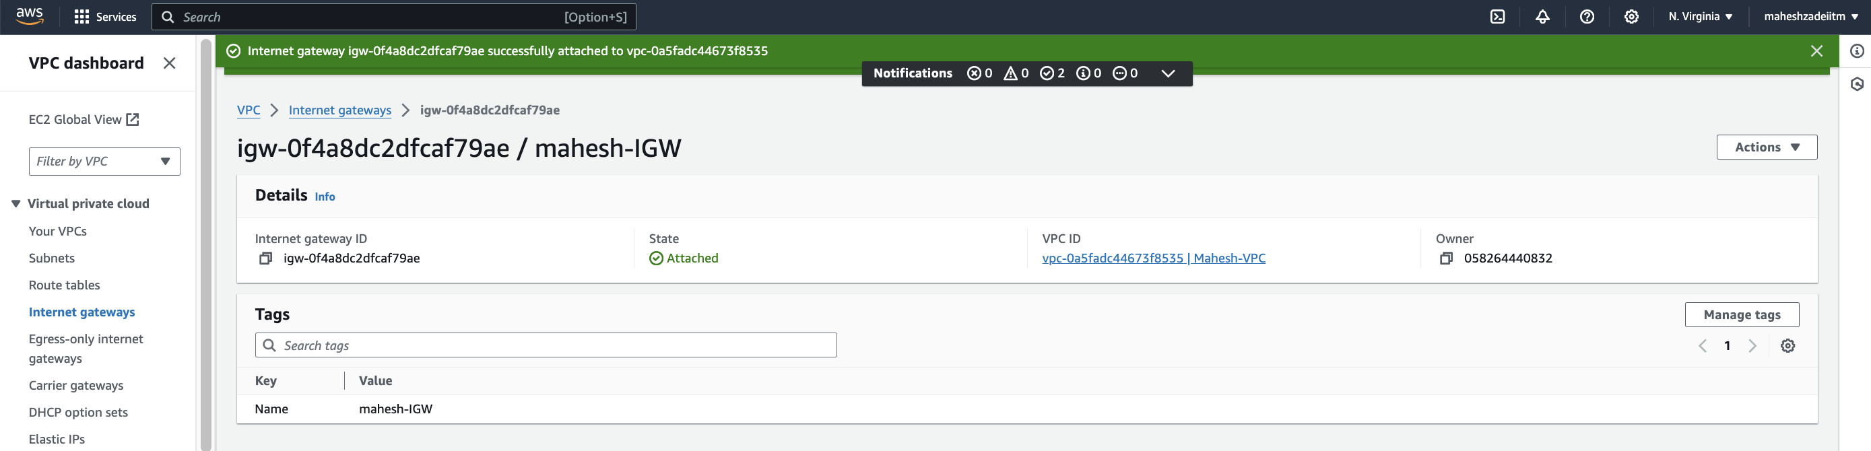

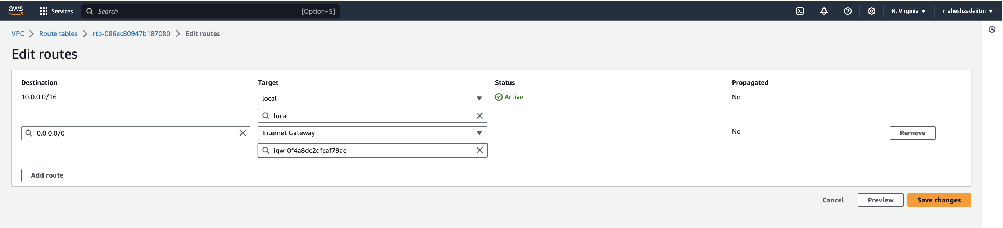

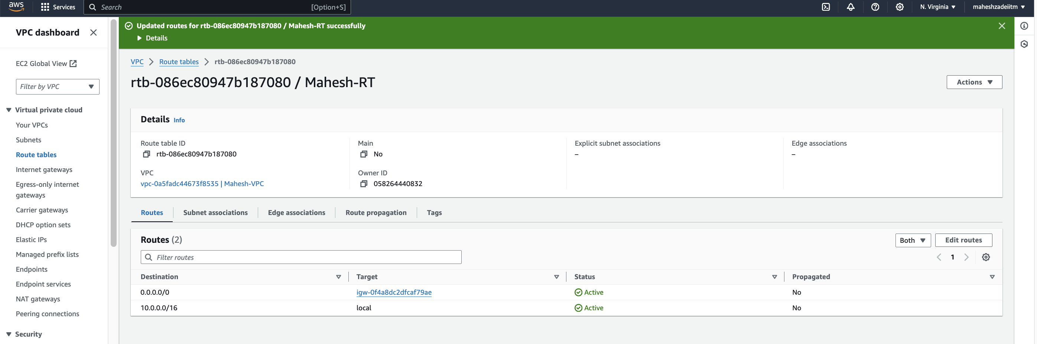

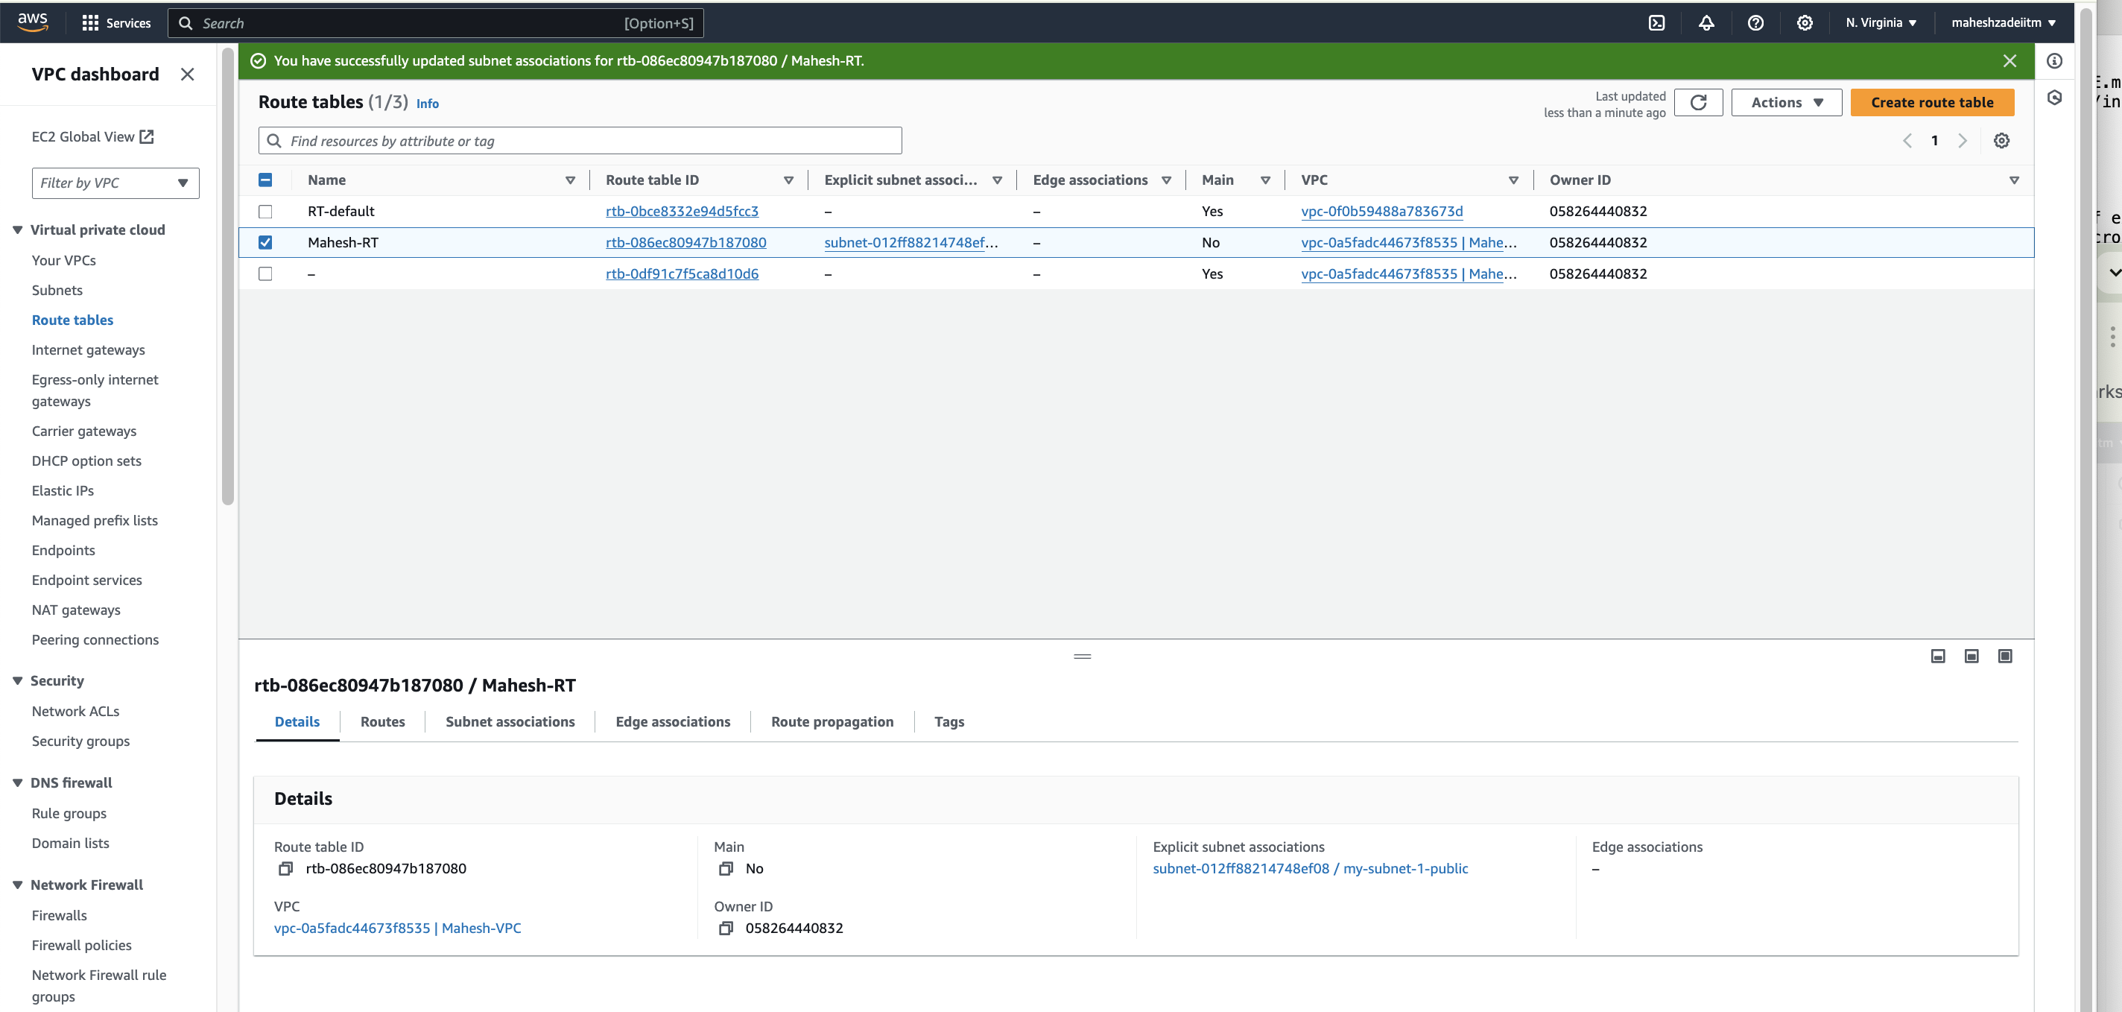

Create a VPC Endpoint:

Go to the VPC service and select "VPC Endpoints."

Click "Create VPC Endpoint."

Choose "Interface" as the endpoint type.

Select your VPC and subnet.

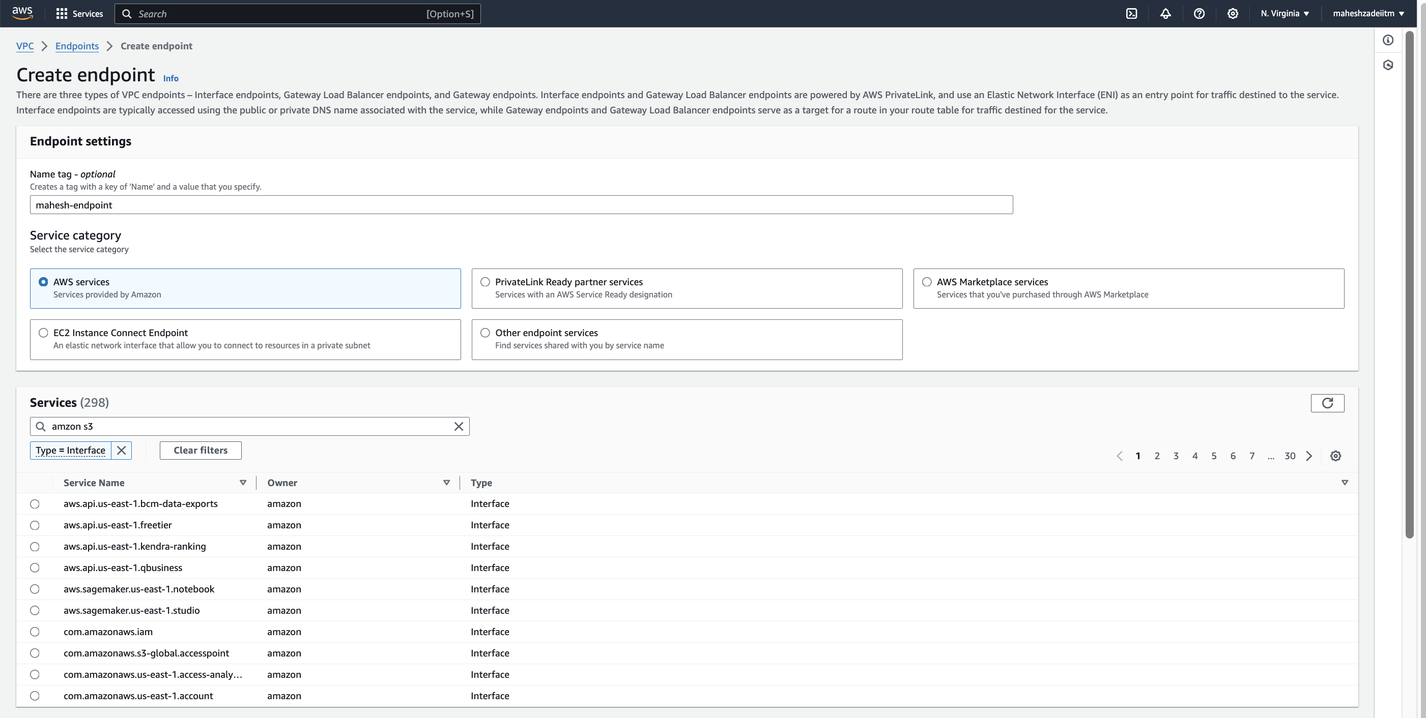

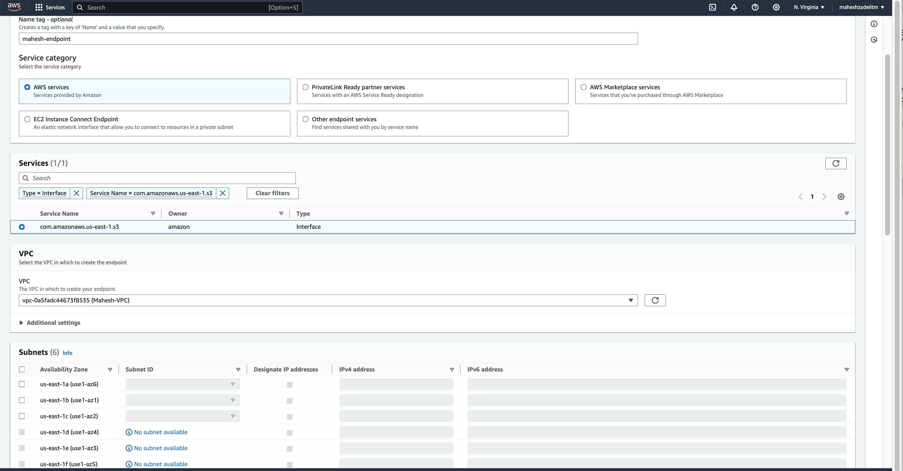

For the service, choose "Amazon S3."

Specify a private IP address for the endpoint.

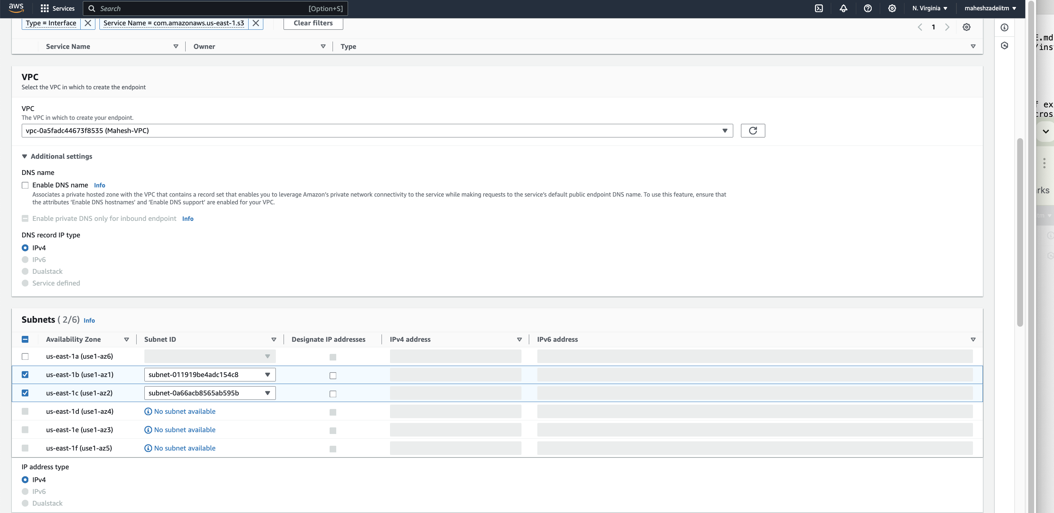

Review and create the endpoint.

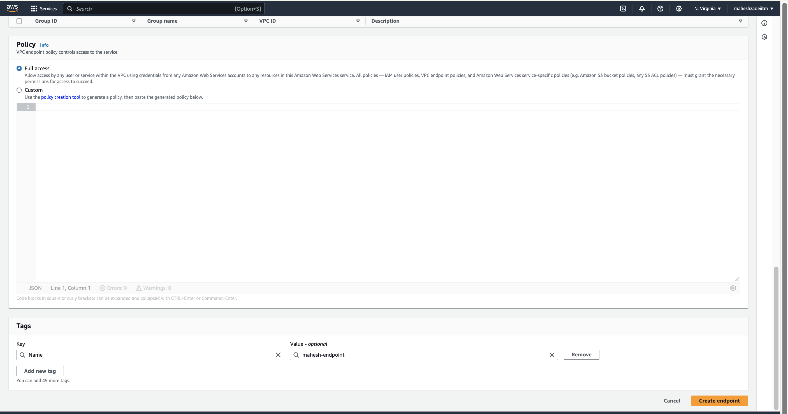

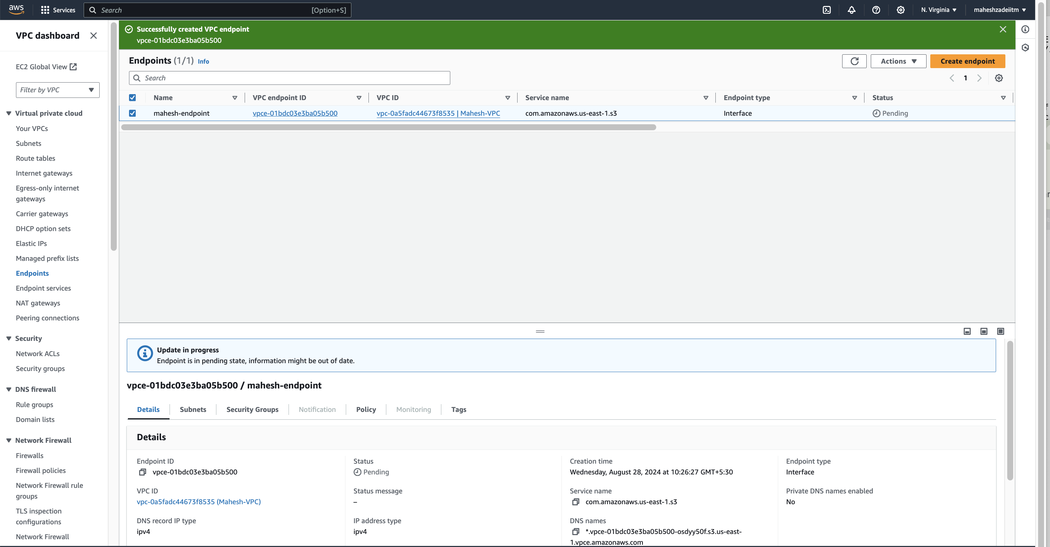

Launch an EC2 instance in the same subnet as your VPC endpoint.

Ensure the instance has the necessary IAM permissions to access S3.

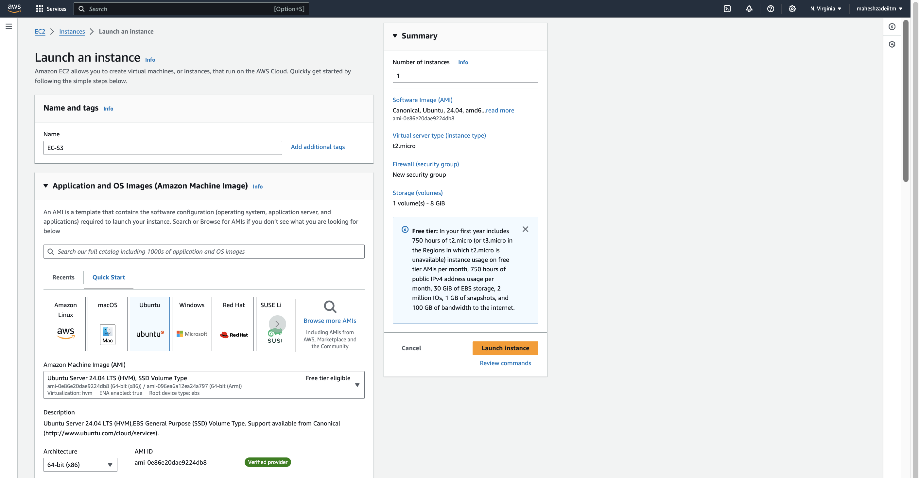

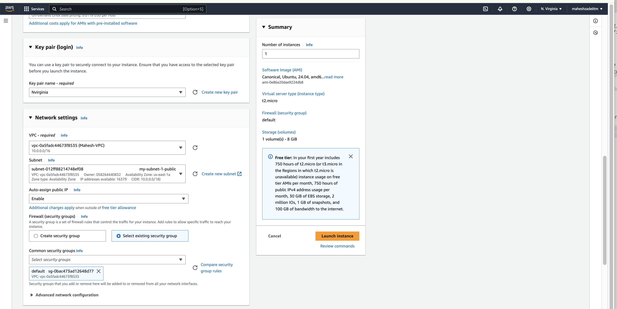

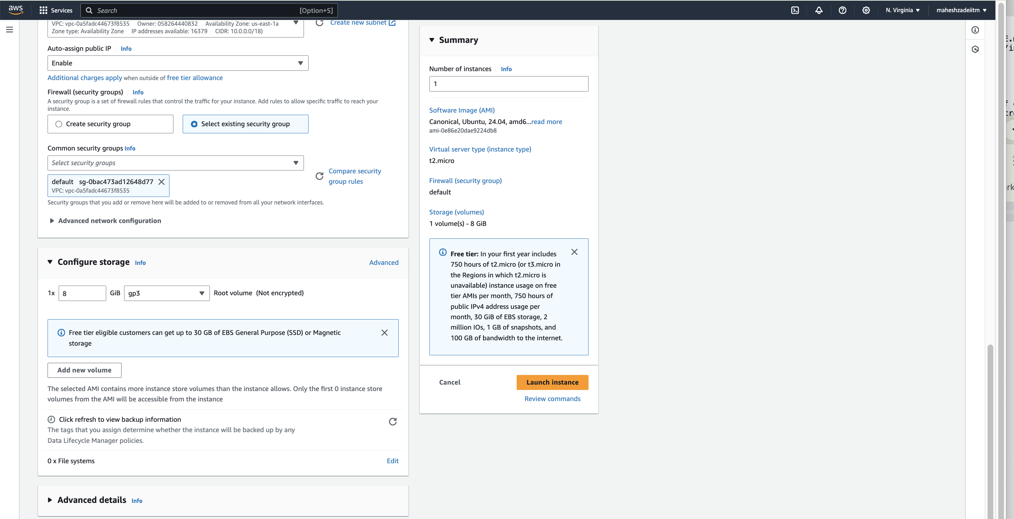

Launch Instance

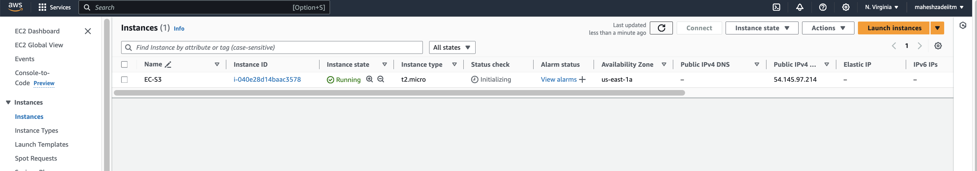

Access S3 from the EC2 Instance

Connect to your EC2 instance using SSH.

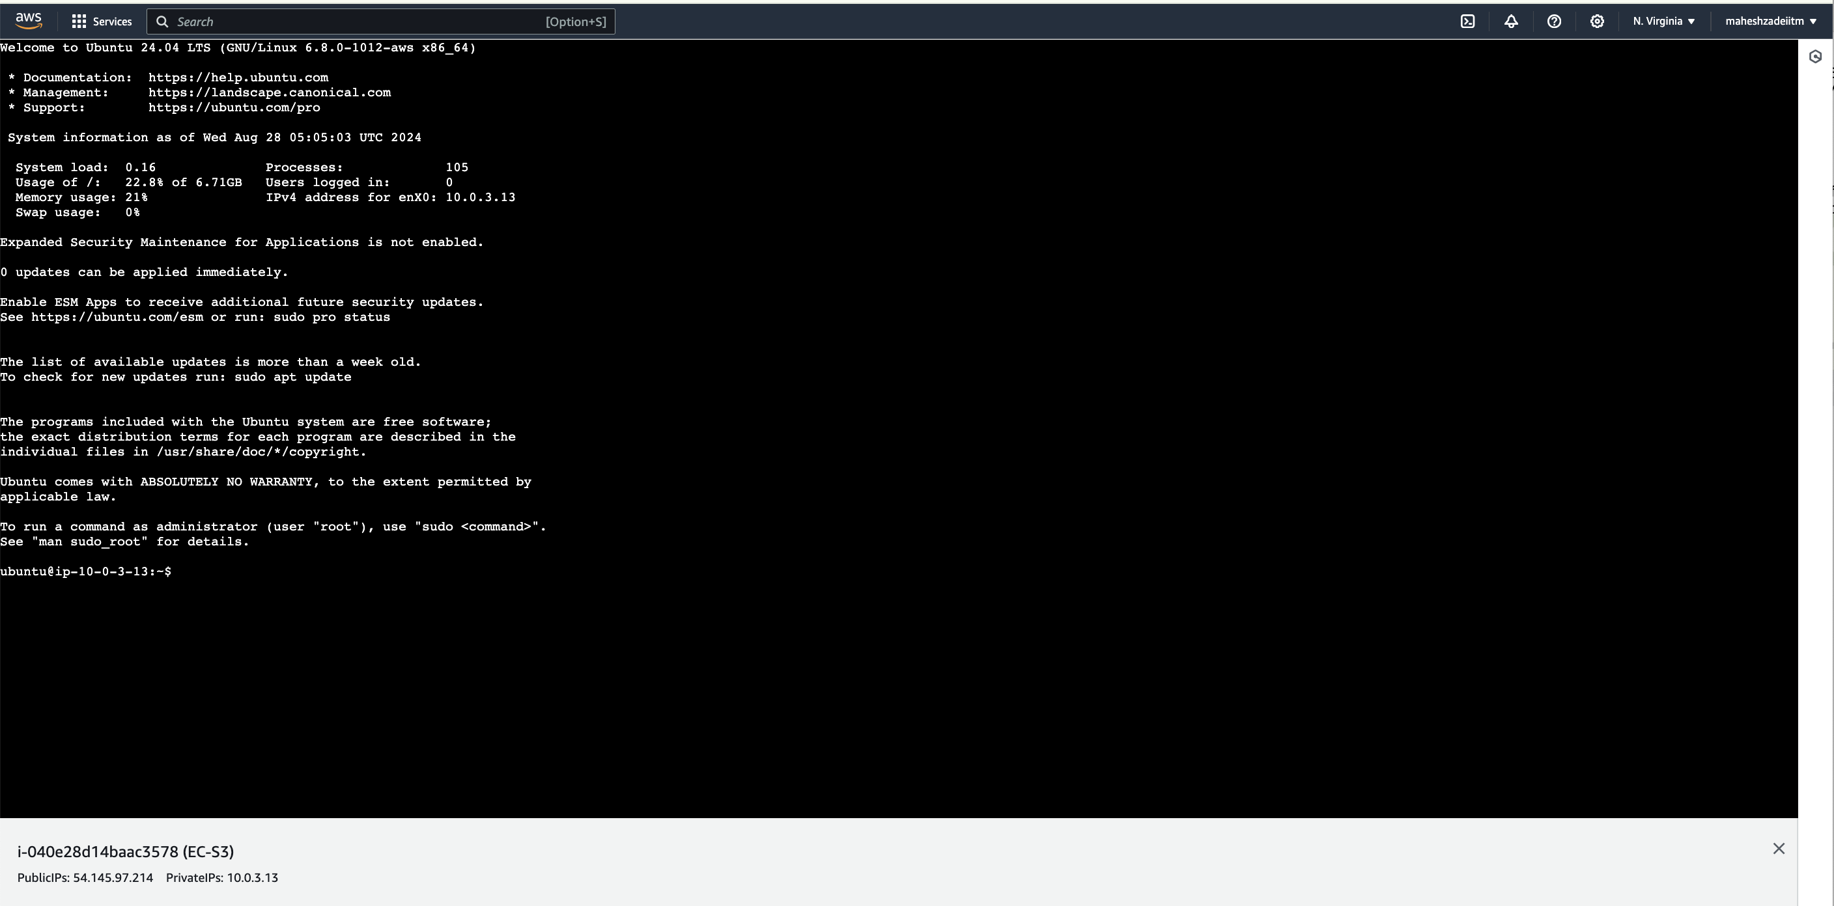

Use the AWS CLI to interact with S3. For example, to list S3 buckets:

By the command. Aws s3 ls

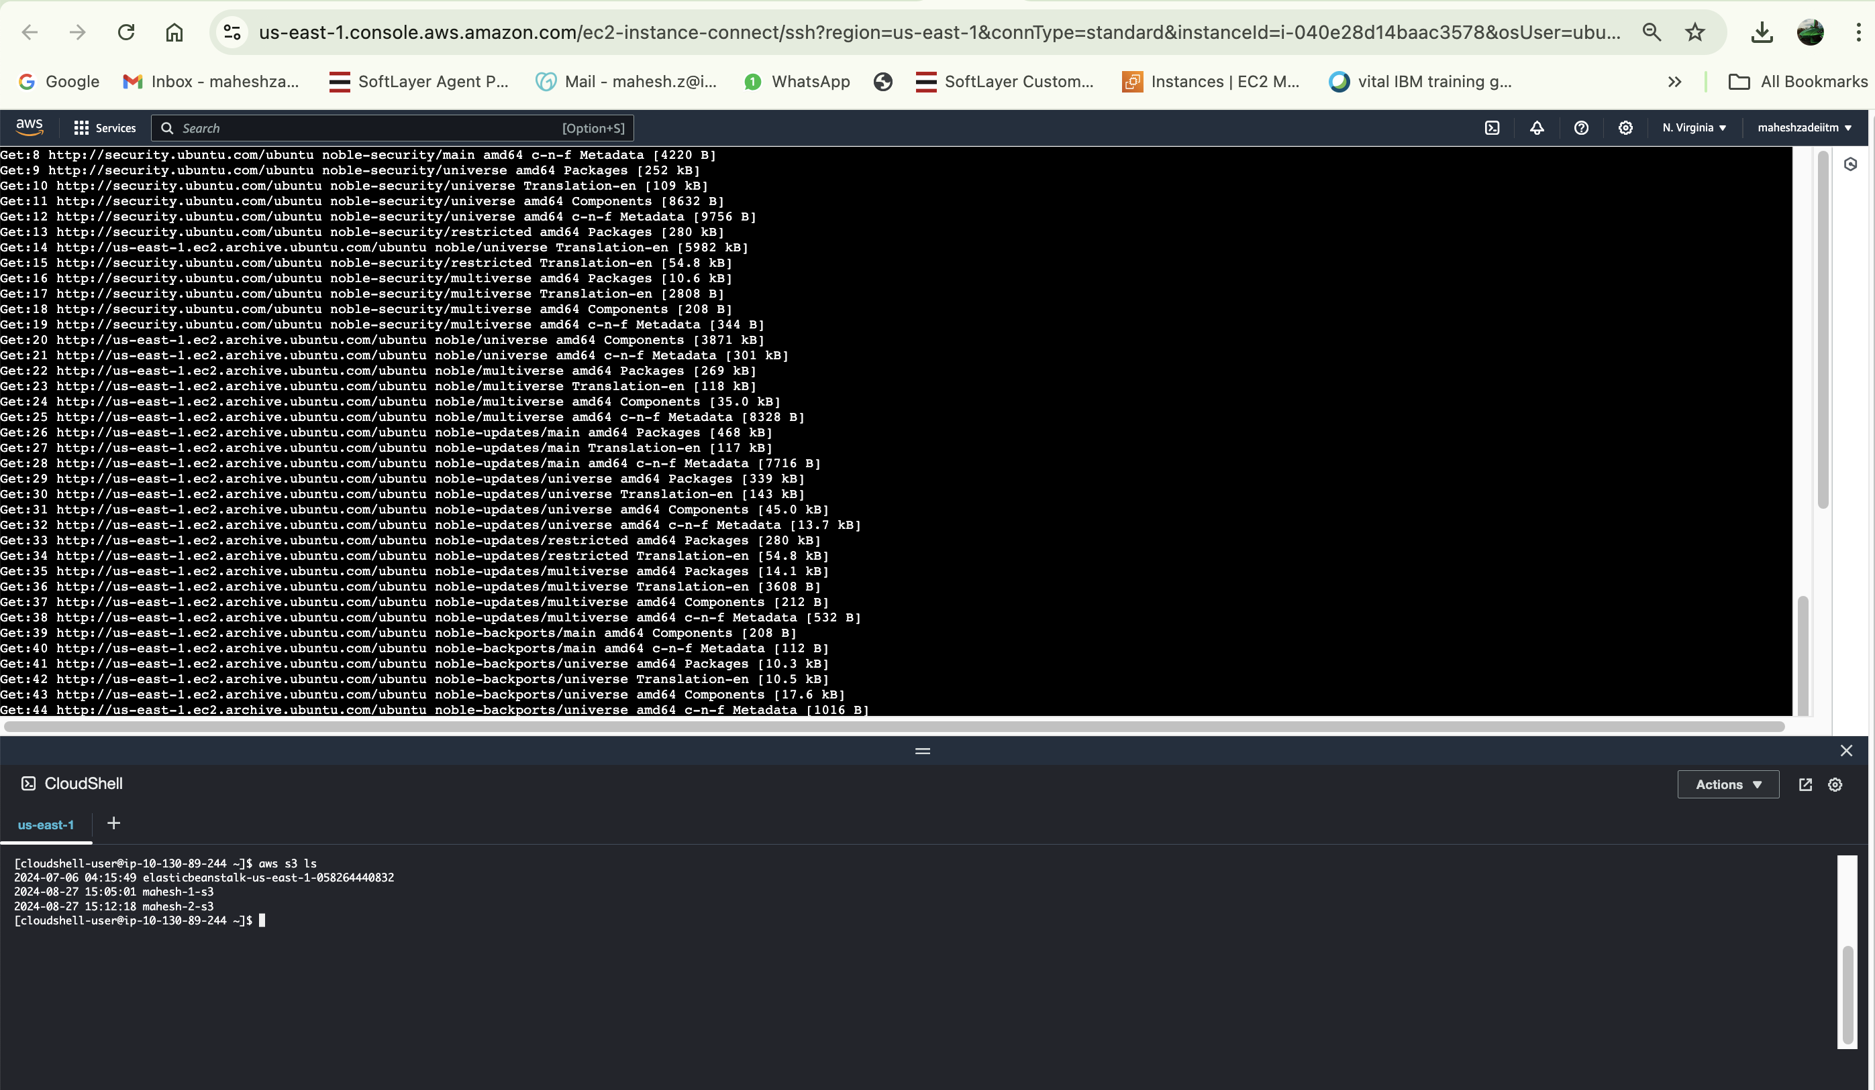

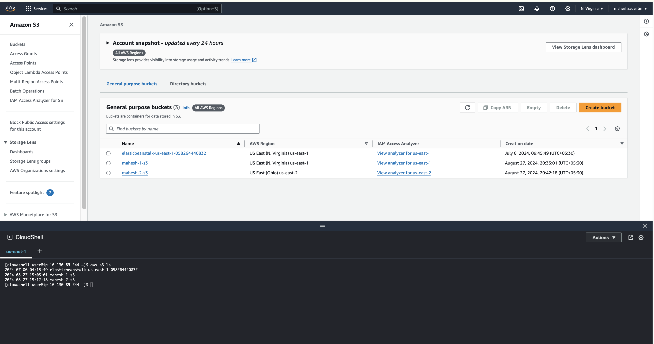

Thanks